We noted that there were some dates that was causing errors as we were running our reporting. You will notice that there are a couple of points that show the 6th of July and then the next point is the 7th of June. We went ahead and changed those two June points to be in July like the data around it. We wanted to check with you and make sure that was correct.

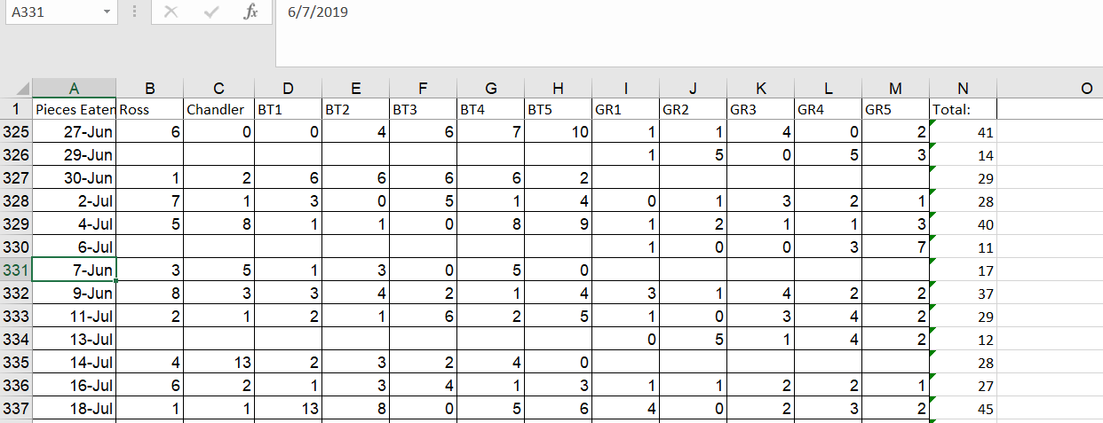

We also noticed that there was another date that seemed to be input wrong that you will see below. All of the dates around it are 2018 and this one was 2008 in the drops AND targets data and so we assumed it was supposed to be 2018 and changed it:  
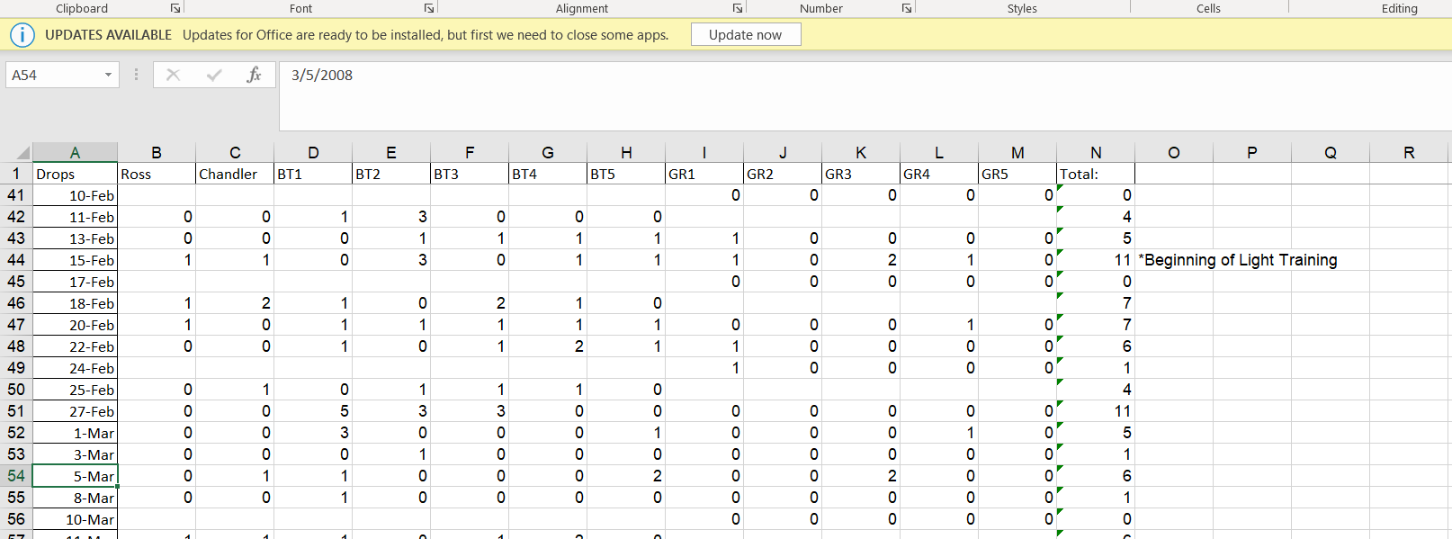

We also noticed this one that has 2017 as the year and all of the dates around it were 2018 in both Targets and drops data, so we changed it to 2018:

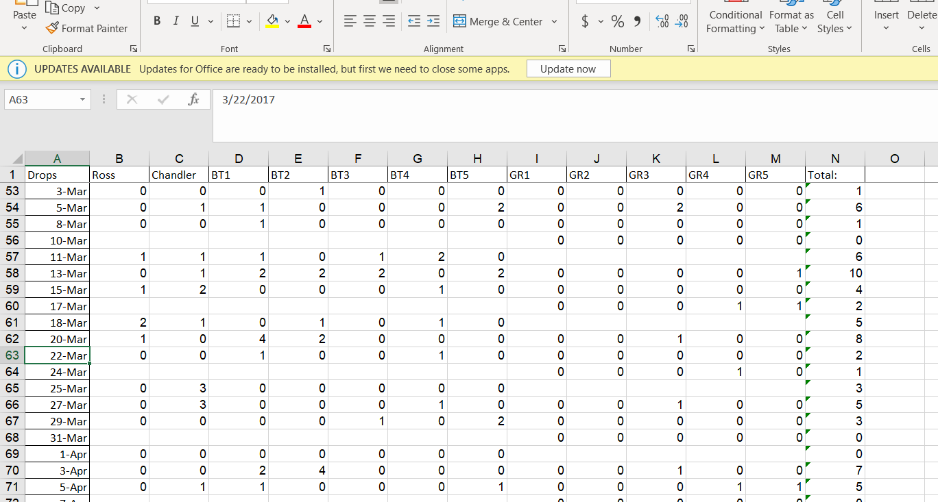

We also noticed in all 3 datasets that there were some dates that were off. We were in May 2019 and then all of the sudden the days and months go in regular order but it changes to 2020. This goes all the way until the new year and it starts back over but at 1/1/2020, so we have multiple days listed for 2020. So we changed all those dates to 2019. Please correct us if we were wrong in doing that:  
